- If not using the C64 Saver Add-on Board (In Development)
  - Pin headers are not required
  - Be sure to install 2 jumpers as indicated in the following diagram
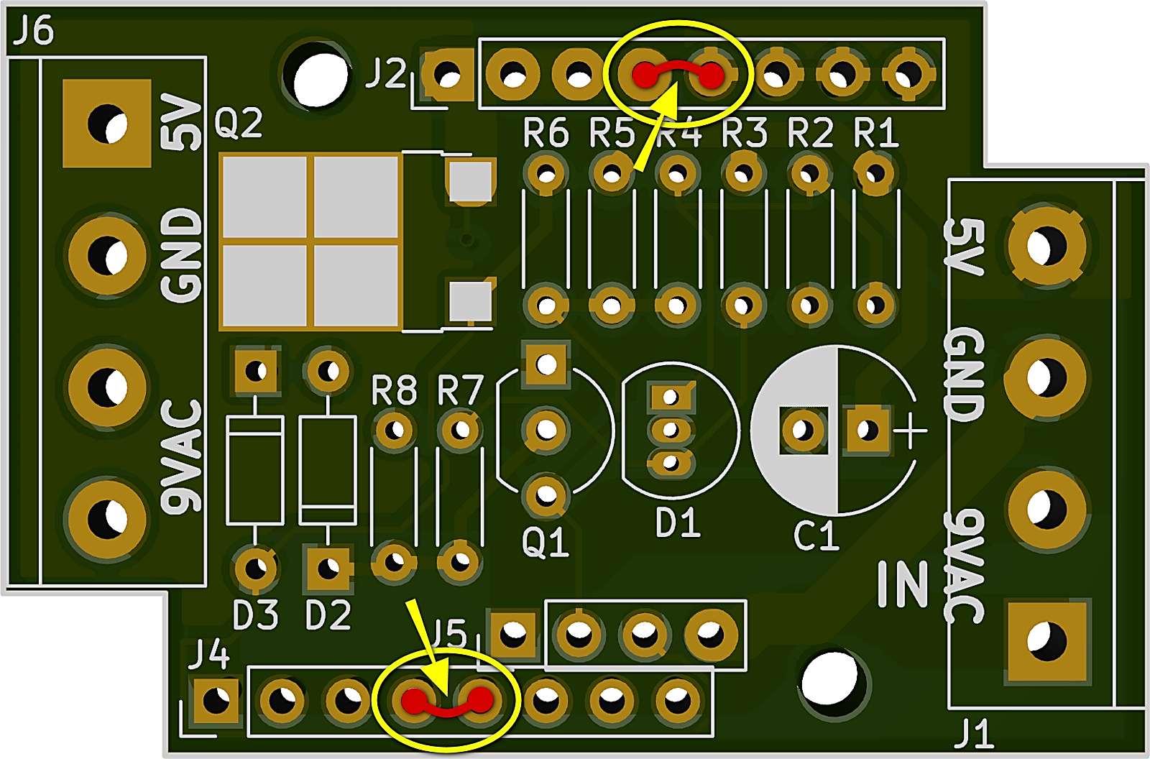
- DIN Connector Wiring Reference
  - 9VAC wires connect to pics 6 & 7
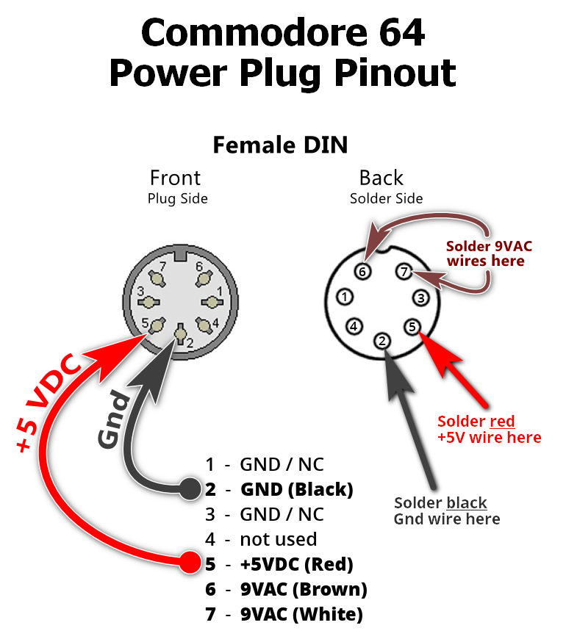
- Component Layout Reference

